LAPORAN PRAKTIKUM
APLIKASI BERBASIS PLATFORM

MODUL 2, 3, 4
HTML & CSS


Disusun oleh:
NAUFAL ZAKI
2311102120
S1 IF-11-06

Dosen Pengampu:
Dedy Agung Prabowo, S.Kom., M.Kom

PROGRAM STUDI S1 TEKNIK INFORMATIKA
FAKULTAS DIREKTORAT KAMPUS PURWOKERTO
UNIVERSITAS TELKOM
2026
LINK GIT : ...........

MODUL 2, 3, 4
HTML & CSS
- Buatlah sebuah tampilan home page/landing page website bebas. Tidak ada ketentuan warna, layout, maupun isi konten. Harus mengimplementasikan html dan css.
  - Code
Index.html
<!doctype html>
<html lang="en">
<head>
<meta charset="UTF-8" />
<meta name="viewport" content="width=device-width, initial-scale=1.0" />
<title>NaufalZaki | Landing Page</title>
<link rel="stylesheet" href="style.css" />
</head>
<body>
<header class="navbar">
<div class="container nav-wrapper">
<h1 class="logo">Zaki Corp</h1>
<nav>
<ul class="nav-menu">
<li><a href="#home">Home</a></li>
<li><a href="#fitur">Fitur</a></li>
<li><a href="#tentang">Tentang</a></li>
<li><a href="#kontak">Kontak</a></li>
</ul>
</nav>
</div>
</header>

<main>
<section class="hero" id="home">
<div class="container hero-content">
<div class="hero-text">
<p class="tag">Website Modern & Responsif</p>
<h2>
Lorem ipsum, dolor sit amet consectetur adipisicing elit.
Aspernatur deserunt est atque
</h2>
<p>
Lorem ipsum dolor sit amet, consectetur adipisicing elit. Soluta,
in. Sapiente facilis nihil
</p>
<div class="hero-buttons">
<a href="#fitur" class="btn btn-primary">Lihat Fitur</a>
<a href="#kontak" class="btn btn-secondary">Hubungi Kami</a>
</div>
</div>
<div class="hero-card">
<div class="card">
<h3>Launch Faster</h3>
<p>Lorem ipsum dolor, sit amet consectetur adipisicing elit.</p>
</div>
</div>
</div>
</section>

<section class="features" id="fitur">
<div class="container">
<h2 class="section-title">Fitur Unggulan</h2>
<div class="feature-grid">
<article class="feature-box">
<h3>Responsif</h3>
<p>Tampilan responsif</p>
</article>
<article class="feature-box">
<h3>Modern</h3>
<p>Dengan desain modern</p>
</article>
<article class="feature-box">
<h3>Cepat</h3>
<p>Dapat dimuat dengan cepat</p>
</article>
</div>
</div>
</section>

<section class="about" id="tentang">
<div class="container about-content">
<div>
<h2 class="section-title">Tentang Website Ini</h2>
<p>
Pemenuhan tugas CSS dan HTML untuk Mata Kuliah Aplikasi Berbasis
Platform
</p>
</div>
</div>
</section>

<section class="contact" id="kontak">
<div class="container">
<h2 class="section-title">Kontak</h2>
<p class="contact-text">Button doang, bukan email</p>
<a href="" class="btn btn-primary">Email Kami</a>
</div>
</section>
</main>

<footer class="footer">
<div class="container">
<p>&copy; 2026 Zaki Corp. All rights reserved.</p>
</div>
</footer>
</body>
</html>

style.css
* {
margin: 0;
padding: 0;
box-sizing: border-box;
}

body {
font-family: Arial, sans-serif;
line-height: 1.6;
background-color: #f7f9fc;
color: #1f2937;
}

a {
text-decoration: none;
color: inherit;
}

.container {
width: 90%;
max-width: 1100px;
margin: 0 auto;
}

.navbar {
background-color: #ffffff;
box-shadow: 0 2px 10px rgba(0, 0, 0, 0.06);
position: sticky;
top: 0;
z-index: 100;
}

.nav-wrapper {
display: flex;
justify-content: space-between;
align-items: center;
padding: 18px 0;
}

.logo {
font-size: 1.5rem;
color: #2563eb;
}

.nav-menu {
display: flex;
gap: 20px;
list-style: none;
}

.nav-menu a {
font-weight: 600;
transition: 0.3s;
}

.nav-menu a:hover {
color: #2563eb;
}

.hero {
padding: 80px 0;
background: linear-gradient(135deg, #dbeafe, #eff6ff);
}

.hero-content {
display: grid;
grid-template-columns: 1.2fr 1fr;
gap: 40px;
align-items: center;
}

.tag {
display: inline-block;
background-color: #2563eb;
color: #fff;
padding: 8px 14px;
border-radius: 999px;
font-size: 0.9rem;
margin-bottom: 20px;
}

.hero-text h2 {
font-size: 2.8rem;
margin-bottom: 20px;
line-height: 1.2;
}

.hero-text p {
margin-bottom: 24px;
color: #4b5563;
}

.hero-buttons {
display: flex;
gap: 14px;
flex-wrap: wrap;
}

.btn {
display: inline-block;
padding: 12px 22px;
border-radius: 10px;
font-weight: bold;
transition: 0.3s;
}

.btn-primary {
background-color: #2563eb;
color: #fff;
}

.btn-primary:hover {
background-color: #1d4ed8;
}

.btn-secondary {
background-color: #ffffff;
color: #2563eb;
border: 2px solid #2563eb;
}

.btn-secondary:hover {
background-color: #2563eb;
color: #fff;
}

.hero-card .card {
background-color: #ffffff;
padding: 32px;
border-radius: 20px;
box-shadow: 0 12px 30px rgba(37, 99, 235, 0.12);
}

.hero-card h3 {
margin-bottom: 12px;
font-size: 1.5rem;
}

.features,
.about,
.contact {
padding: 80px 0;
}

.section-title {
font-size: 2rem;
margin-bottom: 24px;
text-align: center;
}

.feature-grid {
display: grid;
grid-template-columns: repeat(3, 1fr);
gap: 24px;
margin-top: 30px;
}

.feature-box {
background-color: #ffffff;
padding: 28px;
border-radius: 18px;
box-shadow: 0 8px 24px rgba(0, 0, 0, 0.06);
transition: transform 0.3s;
}

.feature-box:hover {
transform: translateY(-6px);
}

.feature-box h3 {
margin-bottom: 12px;
color: #2563eb;
}

.about-content {
text-align: center;
max-width: 800px;
}

.contact {
text-align: center;
background-color: #eff6ff;
}

.contact-text {
margin-bottom: 20px;
color: #4b5563;
}

.footer {
background-color: #111827;
color: #ffffff;
text-align: center;
padding: 22px 0;
}

/* Responsive */
@media (max-width: 900px) {
.hero-content {
grid-template-columns: 1fr;
}

.feature-grid {
grid-template-columns: 1fr;
}

.hero-text h2 {
font-size: 2.2rem;
}
}

@media (max-width: 600px) {
.nav-wrapper {
flex-direction: column;
gap: 12px;
}

.nav-menu {
flex-wrap: wrap;
justify-content: center;
}

.hero {
padding: 60px 0;
}

.hero-text h2 {
font-size: 1.8rem;
}
}

* {
margin: 0;
padding: 0;
box-sizing: border-box;
}

body {
font-family: Arial, sans-serif;
line-height: 1.6;
background-color: #f7f9fc;
color: #1f2937;
}

a {
text-decoration: none;
color: inherit;
}

.container {
width: 90%;
max-width: 1100px;
margin: 0 auto;
}

.navbar {
background-color: #ffffff;
box-shadow: 0 2px 10px rgba(0, 0, 0, 0.06);
position: sticky;
top: 0;
z-index: 100;
}

.nav-wrapper {
display: flex;
justify-content: space-between;
align-items: center;
padding: 18px 0;
}

.logo {
font-size: 1.5rem;
color: #2563eb;
}

.nav-menu {
display: flex;
gap: 20px;
list-style: none;
}

.nav-menu a {
font-weight: 600;
transition: 0.3s;
}

.nav-menu a:hover {
color: #2563eb;
}

.hero {
padding: 80px 0;
background: linear-gradient(135deg, #dbeafe, #eff6ff);
}

.hero-content {
display: grid;
grid-template-columns: 1.2fr 1fr;
gap: 40px;
align-items: center;
}

.tag {
display: inline-block;
background-color: #2563eb;
color: #fff;
padding: 8px 14px;
border-radius: 999px;
font-size: 0.9rem;
margin-bottom: 20px;
}

.hero-text h2 {
font-size: 2.8rem;
margin-bottom: 20px;
line-height: 1.2;
}

.hero-text p {
margin-bottom: 24px;
color: #4b5563;
}

.hero-buttons {
display: flex;
gap: 14px;
flex-wrap: wrap;
}

.btn {
display: inline-block;
padding: 12px 22px;
border-radius: 10px;
font-weight: bold;
transition: 0.3s;
}

.btn-primary {
background-color: #2563eb;
color: #fff;
}

.btn-primary:hover {
background-color: #1d4ed8;
}

.btn-secondary {
background-color: #ffffff;
color: #2563eb;
border: 2px solid #2563eb;
}

.btn-secondary:hover {
background-color: #2563eb;
color: #fff;
}

.hero-card .card {
background-color: #ffffff;
padding: 32px;
border-radius: 20px;
box-shadow: 0 12px 30px rgba(37, 99, 235, 0.12);
}

.hero-card h3 {
margin-bottom: 12px;
font-size: 1.5rem;
}

.features,
.about,
.contact {
padding: 80px 0;
}

.section-title {
font-size: 2rem;
margin-bottom: 24px;
text-align: center;
}

.feature-grid {
display: grid;
grid-template-columns: repeat(3, 1fr);
gap: 24px;
margin-top: 30px;
}

.feature-box {
background-color: #ffffff;
padding: 28px;
border-radius: 18px;
box-shadow: 0 8px 24px rgba(0, 0, 0, 0.06);
transition: transform 0.3s;
}

.feature-box:hover {
transform: translateY(-6px);
}

.feature-box h3 {
margin-bottom: 12px;
color: #2563eb;
}

.about-content {
text-align: center;
max-width: 800px;
}

.contact {
text-align: center;
background-color: #eff6ff;
}

.contact-text {
margin-bottom: 20px;
color: #4b5563;
}

.footer {
background-color: #111827;
color: #ffffff;
text-align: center;
padding: 22px 0;
}

/* Responsive */
@media (max-width: 900px) {
.hero-content {
grid-template-columns: 1fr;
}

.feature-grid {
grid-template-columns: 1fr;
}

.hero-text h2 {
font-size: 2.2rem;
}
}

@media (max-width: 600px) {
.nav-wrapper {
flex-direction: column;
gap: 12px;
}

.nav-menu {
flex-wrap: wrap;
justify-content: center;
}

.hero {
padding: 60px 0;
}

.hero-text h2 {
font-size: 1.8rem;
}
}

* {
margin: 0;
padding: 0;
box-sizing: border-box;
}

body {
font-family: Arial, sans-serif;
line-height: 1.6;
background-color: #f7f9fc;
color: #1f2937;
}

a {
text-decoration: none;
color: inherit;
}

.container {
width: 90%;
max-width: 1100px;
margin: 0 auto;
}

.navbar {
background-color: #ffffff;
box-shadow: 0 2px 10px rgba(0, 0, 0, 0.06);
position: sticky;
top: 0;
z-index: 100;
}

.nav-wrapper {
display: flex;
justify-content: space-between;
align-items: center;
padding: 18px 0;
}

.logo {
font-size: 1.5rem;
color: #2563eb;
}

.nav-menu {
display: flex;
gap: 20px;
list-style: none;
}

.nav-menu a {
font-weight: 600;
transition: 0.3s;
}

.nav-menu a:hover {
color: #2563eb;
}

.hero {
padding: 80px 0;
background: linear-gradient(135deg, #dbeafe, #eff6ff);
}

.hero-content {
display: grid;
grid-template-columns: 1.2fr 1fr;
gap: 40px;
align-items: center;
}

.tag {
display: inline-block;
background-color: #2563eb;
color: #fff;
padding: 8px 14px;
border-radius: 999px;
font-size: 0.9rem;
margin-bottom: 20px;
}

.hero-text h2 {
font-size: 2.8rem;
margin-bottom: 20px;
line-height: 1.2;
}

.hero-text p {
margin-bottom: 24px;
color: #4b5563;
}

.hero-buttons {
display: flex;
gap: 14px;
flex-wrap: wrap;
}

.btn {
display: inline-block;
padding: 12px 22px;
border-radius: 10px;
font-weight: bold;
transition: 0.3s;
}

.btn-primary {
background-color: #2563eb;
color: #fff;
}

.btn-primary:hover {
background-color: #1d4ed8;
}

.btn-secondary {
background-color: #ffffff;
color: #2563eb;
border: 2px solid #2563eb;
}

.btn-secondary:hover {
background-color: #2563eb;
color: #fff;
}

.hero-card .card {
background-color: #ffffff;
padding: 32px;
border-radius: 20px;
box-shadow: 0 12px 30px rgba(37, 99, 235, 0.12);
}

.hero-card h3 {
margin-bottom: 12px;
font-size: 1.5rem;
}

.features,
.about,
.contact {
padding: 80px 0;
}

.section-title {
font-size: 2rem;
margin-bottom: 24px;
text-align: center;
}

.feature-grid {
display: grid;
grid-template-columns: repeat(3, 1fr);
gap: 24px;
margin-top: 30px;
}

.feature-box {
background-color: #ffffff;
padding: 28px;
border-radius: 18px;
box-shadow: 0 8px 24px rgba(0, 0, 0, 0.06);
transition: transform 0.3s;
}

.feature-box:hover {
transform: translateY(-6px);
}

.feature-box h3 {
margin-bottom: 12px;
color: #2563eb;
}

.about-content {
text-align: center;
max-width: 800px;
}

.contact {
text-align: center;
background-color: #eff6ff;
}

.contact-text {
margin-bottom: 20px;
color: #4b5563;
}

.footer {
background-color: #111827;
color: #ffffff;
text-align: center;
padding: 22px 0;
}

/* Responsive */
@media (max-width: 900px) {
.hero-content {
grid-template-columns: 1fr;
}

.feature-grid {
grid-template-columns: 1fr;
}

.hero-text h2 {
font-size: 2.2rem;
}
}

@media (max-width: 600px) {
.nav-wrapper {
flex-direction: column;
gap: 12px;
}

.nav-menu {
flex-wrap: wrap;
justify-content: center;
}

.hero {
padding: 60px 0;
}

.hero-text h2 {
font-size: 1.8rem;
}
}

  - Screenshoot Output
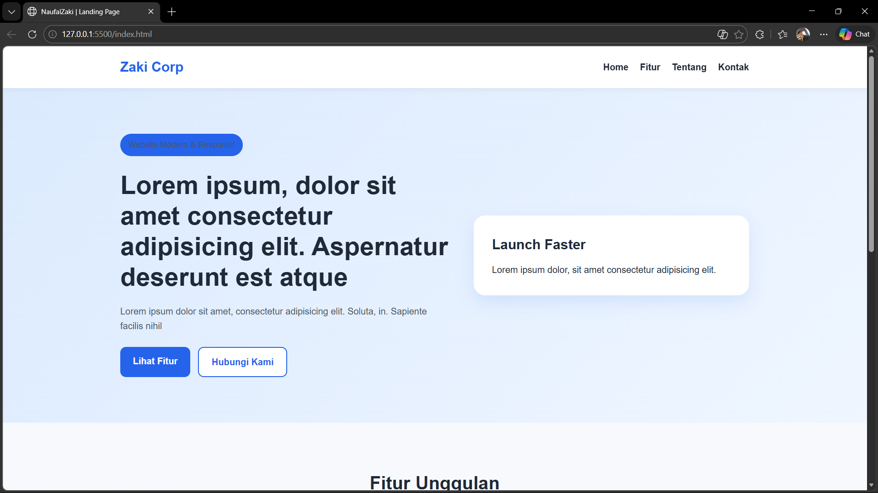
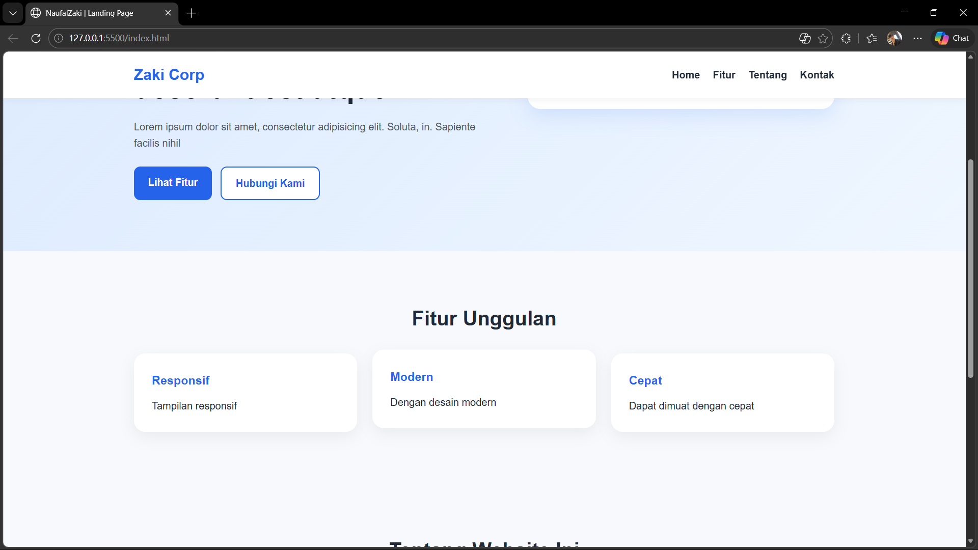
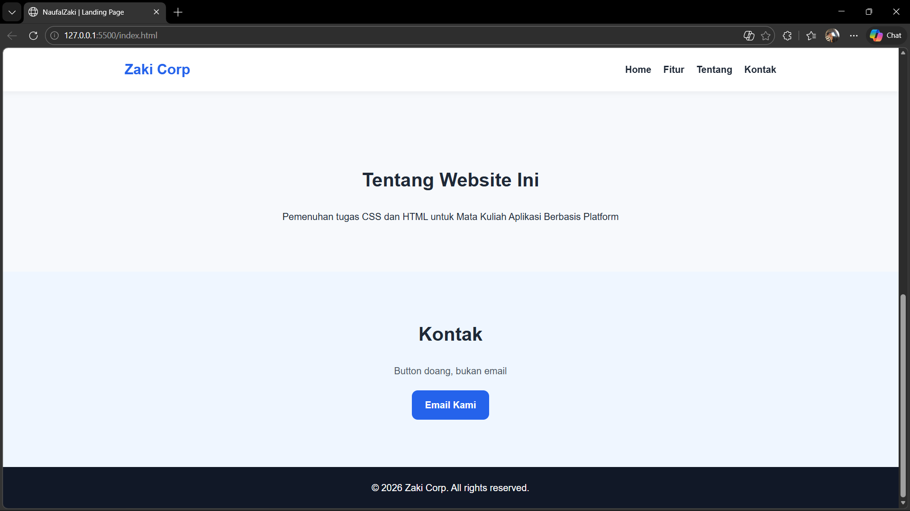

  - Penjelasan dari code dan output
Kode di atas merupakan sebuah code html dan css yang membuat sebuah home page atau landing page dari sebuah website. Pada file index.html, elemen seperti navbar, hero section, fitur, tentang, kontak, dan footer disusun secara berurutan agar halaman memiliki alur yang jelas dari atas ke bawah, sedangkan file style.css memberi warna, jarak, ukuran teks, bayangan, serta layout grid dan flex supaya isi HTML yang awalnya hanya berupa susunan elemen biasa berubah menjadi tampilan website yang modern, rapi, dan responsif.
Korelasi antara kode dan outputnya terlihat langsung pada setiap bagian halaman, misalnya header dengan class navbar akan tampil sebagai navigasi di bagian atas karena di CSS diberi latar putih, bayangan, dan posisi sticky, lalu bagian hero tampil menonjol dengan latar gradasi biru karena class tersebut diatur menggunakan background: linear-gradient(...). Begitu juga tombol, kartu, dan kotak fitur yang ada di HTML akan terlihat lebih hidup pada output karena CSS menambahkan padding, border-radius, box-shadow, serta efek hover, sehingga struktur yang dibuat di HTML menjadi sebuah halaman utama website yang enak dilihat dan mudah digunakan.

